HTML lists

**Table of content**

* What is HTML list?
* How to create HTML list?
* What are the types of HTML list use in HTML document?
* Explain Type Attribute in HTML list?
* Explain Nested list in HTML?

**What is HTML list?**

HTML language allows the user to represent and maintain the data or information or a content which is to be in a sequential manner. HTML list is a concept of maintaining your data in a proper sequence means in an ordered way or unordered manner.

HTML lists supports three types of lists-

**Ordered list –**

Ordered list is a concept in which the list item is arrange in an ordered format. It allows us to give a specific number or an alphabetical order list to the data items. Ordered list represented by <ol> open and </ol>close tag.

**Example-**

1. List item
2. List item
3. List item
4. List item

**Unordered list –**

Unordered list contains the data item which is not in the ordered format but in the bullet format. Unordered list represented by <ul> open and </ul>close tag.

**Example-**

* List item
* List item
* List item
* List item

**Definition list –**

Definition list also known as description list. Definition list contain the list items which is arrange like a dictionary word. The words which are arrange in a dictionary like in alphabetical order same arrange in a definition list at the same time this list is used to give the description along with the list items. Definition list represented by <dl> open and </dl>close tag.

**Example-**

Bread

Coffee

Egg

Milk

**How to create HTML list?**

In HTML document there are three types of lists that are ordered list, unordered list and definition list. These three lists are used to represent data items. For representing data items <li> tag is used. <li> tag is define under the main list tag

**Example-**

Example of ordered list-(List items are in ordered manner)

<!DOCTYPE html>

<html lang="en">

<head>

    <meta charset="UTF-8">

    <meta name="viewport" content="width=device-width, initial-scale=1.0">

    <title>Document</title>

</head>

<body>

    <h1>Example of lists tag</h1>

    <ol>

        <li>list items</li>

        <li>list items</li>

        <li>list items</li>

        <li>list items</li>

    </ol>

</body>

</html>

**Output-**

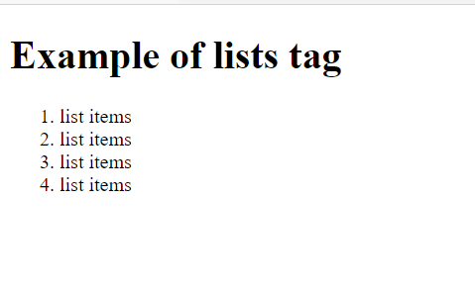

**Example-**

Example of unordered list-( List items are in bullet format)

<!DOCTYPE html>

<html lang="en">

<head>

    <meta charset="UTF-8">

    <meta name="viewport" content="width=device-width, initial-scale=1.0">

    <title>list tag</title>

</head>

<body>

    <h1>Example of lists tag</h1>

    <ul>

        <li>list items</li>

        <li>list items</li>

        <li>list items</li>

        <li>list items</li>

    </ul>

</body>

</html>

**Output-**

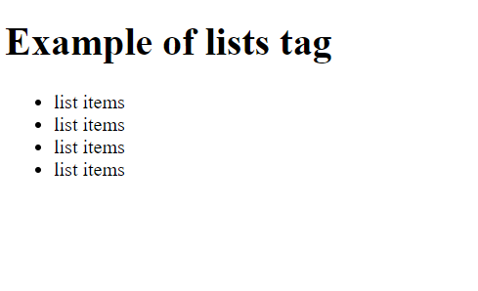

**What are the types of HTML list use in HTML document?**

**Ordered list-**

Ordered list is use for giving ordered serial number to the list items. <ol> tag is use in ordered list to represent list items. List items represented by <li> tag in it.

**Example-**

<!DOCTYPE html>

<html lang="en">

<head>

    <meta charset="UTF-8">

    <meta name="viewport" content="width=device-width, initial-scale=1.0">

    <title>ordered list tag</title>

</head>

<body>

    <h1>what skills do front end developers use</h1>

    <ol>

        <li>HTML</li>

        <li>CSS</li>

        <li>Javascript</li>

        <li>jQuery</li>

        <li>Javascript framework</li>

        <li>Git version control</li>

    </ol>

</body>

</html>

**Output-**

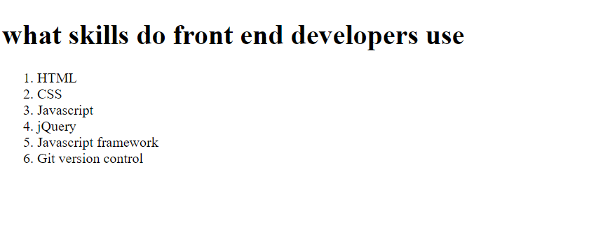

**Unordered list-**

Unordered list is use for representation of the unordered list items. <ul> tag is use in unordered list to represent list items. List items represented by <li> tag in it.

**Example-**

<!DOCTYPE html>

<html lang="en">

<head>

    <meta charset="UTF-8">

    <meta name="viewport" content="width=device-width, initial-scale=1.0">

    <title>unordered list tag</title>

</head>

<body>

    <h1>Top five IT companies in India</h1>

    <ol>

        <li>TCS</li>

        <li>Infosys</li>

        <li>wipro</li>

        <li>HCL</li>

        <li>Tech mahindra</li>

    </ol>

</body>

</html>

**Output-**



**Definition list-**

**Definition list is use for representing the list items along with the description. Definition list consists of open <dt> tag and close </dt> tag which is use to represent list items in the definition list. <dt> tag also consist of open <dd> and close </dd> tag and dd tag is use for representation of description of the particular list iten.**

**Example-**

<!DOCTYPE html>

<html lang="en">

<head>

    <meta charset="UTF-8">

    <meta name="viewport" content="width=device-width, initial-scale=1.0">

    <title>description list tag</title>

</head>

<body>

    <h1>List of protocols use in networking</h1>

    <dl>

        <dt>HTTP</dt>

        <dd>Hyper text transfer protocol</dd>

        <dt>TCP</dt>

        <dd>Transmission control protocol</dd>

        <dt>UDP</dt>

        <dd>User datagram protocol</dd>

        <dt>POP</dt>

        <dd>Post office protocol</dd>

    </dl>

</body>

</html>

**Output-**

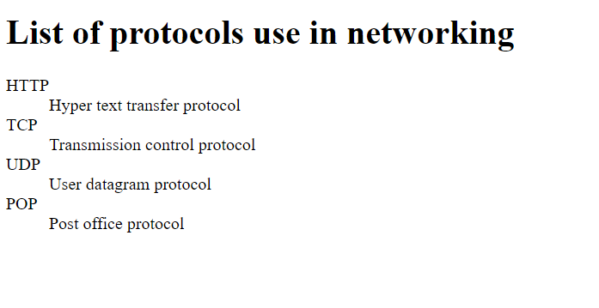

**Explain Type Attribute in HTML list?**

Type attribute is use in both ordered and unordered list items.

Type attribute in ordered list-

<ol type=”A”> - List items will represents in capital latter format.

<ol type=”a”> - List items will represents in small latter format.

<ol type=”I”> - List items will represents in upper case numerical format.

<ol type=”1”> - List items will represents in numerical format starting from 1.

<ol type=”i”> - List items will represents in lower case numerical format.

**Example-**

<!DOCTYPE html>

<html lang="en">

<head>

    <meta charset="UTF-8">

    <meta name="viewport" content="width=device-width, initial-scale=1.0">

    <title>description list tag</title>

</head>

<body>

   <h1>Example Type attribute in ordered list</h1>

    <ol type="1">

        <li>list item</li>

        <li>list item</li>

        <li>list item</li>

    </ol>

    <ol type="a">

        <li>list item</li>

        <li>list item</li>

        <li>list item</li>

    </ol>

    <ol type="I">

        <li>list item</li>

        <li>list item</li>

        <li>list item</li>

    </ol>

    <ol type="A">

        <li>list item</li>

        <li>list item</li>

        <li>list item</li>

    </ol>

</body>

</html>

**Output-**

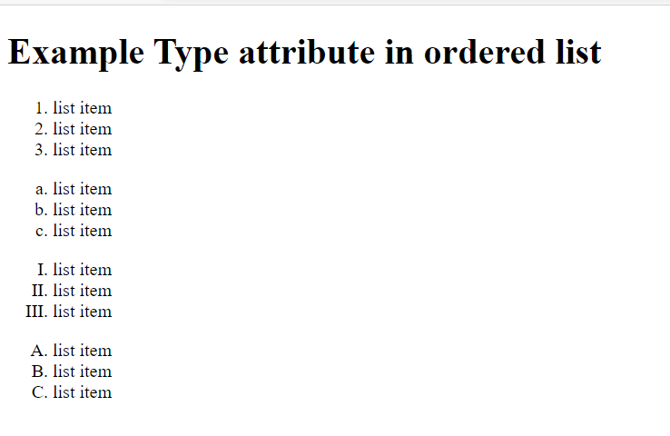

Type attribute in unordered list-

<ul type=”square”> - It will represents the unordered list items in Square type format.

<ul type=”circle”> - It will represents the unordered list items in solid circle type format.

<ul type=”dics”> - It will represents the unordered list items hollow circle type format.

**Example-**

<!DOCTYPE html>

<html lang="en">

<head>

    <meta charset="UTF-8">

    <meta name="viewport" content="width=device-width, initial-scale=1.0">

    <title>description list tag</title>

</head>

<body>

   <h1>Example Type attribute in unordered list</h1>

    <ul type="square">

        <li>list item</li>

        <li>list item</li>

        <li>list item</li>

    </ul>

    <ul type="disc">

        <li>list item</li>

        <li>list item</li>

        <li>list item</li>

    </ul>

    <ul type="circle">

        <li>list item</li>

        <li>list item</li>

        <li>list item</li>

    </ul>

</body>

</html>

**Output-**

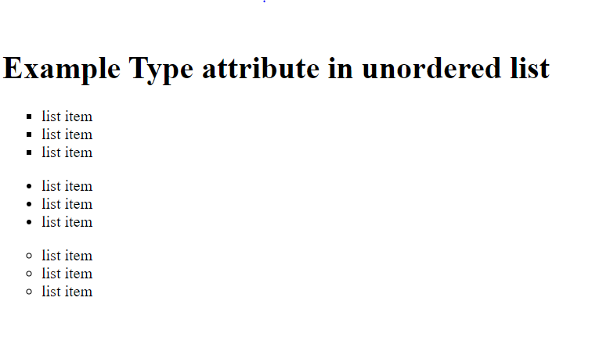

**Explain Nested list in HTML?**

Nested list represents the list within the list.

**Example-**

<!DOCTYPE html>

<html lang="en">

<head>

    <meta charset="UTF-8">

    <meta name="viewport" content="width=device-width, initial-scale=1.0">

    <title>description list tag</title>

</head>

<body>

   <h1>Example of Nested list</h1>

    <ol>

        <li>list item</li>

        <li>list item</li>

        <li>list item</li>

        <ol>

            <li>list item</li>

            <li>list item</li>

        </ol>

    </ol>

</body>

</html>

**Output-**

